December 14th, 2023

To Whom It May Concern,

This letter is intended to act as official confirmation from the Master of Environmental Studies Program at The Evergreen State College that Renae Boisvert has fulfilled all requirements for the MES Degree. Our Program has provided confirmation to the Registration and Records office at Evergreen to confer her MES on her transcript. The Registration and Records office will need time to post her degree to her transcript but please accept this letter as confirmation of her degree earned status until it can be officially processed.

If you have any questions, please contact me at leroyc@evergreen.edu.

Sincerely,
Carri LeRoy

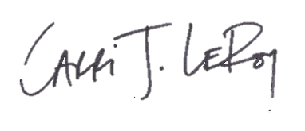
Carri LeRoy, Ph.D.
Director, Master of Environmental Studies Program
leroyc@evergreen.edu

