Request to Present Thesis Research

Master of Environmental Studies
The Evergreen State College

Student Name: Elizabeth Torres____________

Reader Name: Shawn Hazboun____________

Thesis Title (will be used for announcement of presentations): ________________________________________________________________________________________ Returning to Birth Ceremonies & Honoring Our Ecologies____________________________________
________________________________________________________________________________________
Students enrolled in the thesis workshop or with approved research extension to complete their thesis work must receive approval from their thesis reader to make a public presentation of their work.

To present research, the reader must have made comments and requests for change on a complete first draft.

Student Approval:

I have submitted a complete first draft of my thesis. I am ready to present my thesis work.

Student Signature: 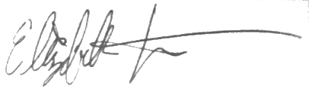

Date: 8/8/2023

I would like to present my thesis project (please check one):

X In-person (on September 7th with virtual option for advisor availability).

Reader Approval:

The above named student has received comments based on my review of a complete first draft. I approve the student’s work and support a public presentation of the research.

Reader Signature:

Date:
*Signed form must be emailed to francisk@evergreen.edu by August 4, 2023. Students should email the Director and cc their faculty reader so the reader may provide their email of approval.

