**Megan Folkers**

**CSTD 12.4**

**1) Working title of your thesis**

-Stormwater Filter Media Containing Granular Material: Effectiveness of Phosphorus Removal

**2) In 250 words or less, summarize the key background information needed to   
understand your research problem and question.**

The city of Olympia, Washington, like many other large urban cities, experiences over 50 inches of rain a year. This stormwater runs along all existing surfaces and exposed potential sources of pollution, picking up excess phosphorus along the way. Exposed surfaces from uncovered dumpsters, roofs, animal feces, vegetative waste, motor oil, impervious surfaces, and endless other sources are coated with stormwater and contaminated with phosphorus before reaching a variety of treatment options and discharge routes. If excess phosphorus is carried by stormwater and introduced to water bodies, this excess nutrient load from urban runoff acts as a catalyst for harmful microbial growth, causing eutrophication or nutrient pollution (Adhikari et al., 2016).

As a result of the drastic surface changes contributing to increased runoff contamination and flooding concerns as detailed above, urban solutions such as stormwater media filters can be a space-saving alternative for urban cities. Stormwater media filters containing granular materials were designed to remove various substances affecting water quality such as phosphorus, as well as filtering fine particles (Egemose, 2018). These filters are most commonly located in urban areas in underground vaults shielded by large cast iron lids.

While these filters are advertised as effective solutions for removing phosphorus from stormwater, the largest company providing these services in Olympia, WA states that 82 percent of total phosphorus is removed from stormwater with their granular media (Contech Engineered Solutions, LLC, 2015). Stormwater filters must be implemented to effectively remove phosphorus as claimed to potentially ease water bodies of eutrophication and other adverse effects.

**3) State your research question(s).**

What is the effectiveness of stormwater media filters in removing phosphorus from urban stormwater runoff?

**4) Situate your research problem within the relevant literature. What is the theoretical   
and/or practical framework of your research problem?**

Stormwater media filters undoubtably popular use throughout urban cities poses question as to what phosphorus removal efficiencies are currently available through the existing systems. An area in Olympia, Washington in the attached photo below demonstrates catch basins individually numbered located throughout roads, city blocks, and sidewalks collecting stormwater and passing it through stormwater media filters (labeled as T) before directly discharging into the nearby bay. Excess phosphorus carried by stormwater will be introduced to the resulting aquatic ecosystem if not treated properly by these filters, where eutrophication and other adverse environmental effects will then take place.  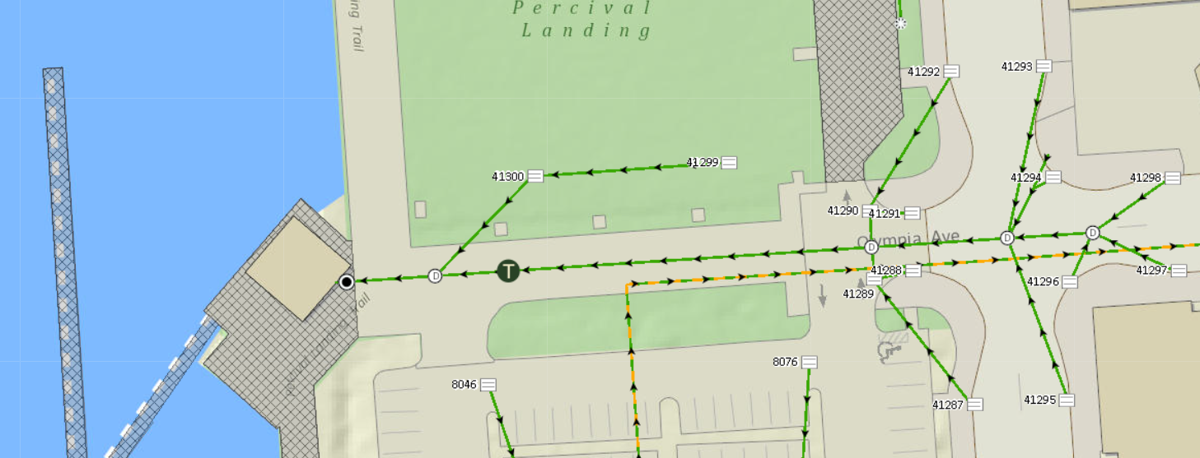

Photo: City of Olympia Private Stormwater Maintenance Program GIS <https://olympiawa.maps.arcgis.com/apps/webappviewer/index.html?id=e33702d6bb554f83b0ff19425baeb854>

While this example stormwater site containing a cartridge filter is designed to filter out excess nutrients such as phosphorus, if the capacity and efficiency of these storm filters are analyzed, then any deficiencies observed can provide evidence of stormwater filter and stormwater drainage system upgrades required. In addition, if phosphorus removal deficiencies are observed then the efficiency of phosphorus removal can be analyzed for not only the granular media, but monitorization and replacement efforts by the relevant owner and jurisdiction.

**5) Explain the significance of this research problem. Why is this research important?   
What are the potential contributions of your work? How might your work advance   
scholarship?**

If phosphorus is not effectively filtered out of stormwater, adverse effects and health hazards can negatively affect water quality, marine life, surrounding vegetation, and human health. Non-point source pollution occurs from stormwater carried pollutants that enter water ways from improper infiltration. Among limiting nutrients, phosphorus is associated as one of the highest concern as it supports microbial growth in receiving waters and can lead to eutrophication or algal growth if present in extreme concentrations (Adhikari et al., 2016)(Wu & Sansalone, 2013)(Wang et al., 2022). Excessive algal growth in water bodies is known to cause blooms toxic to humans and animals and lead to fish death as well (Smith et al., 2020).

For those unfamiliar with stormwater disposal and filtration pathways, it is admittingly difficult to identify or observe a potential stormwater disposal problem that is below your feet underground, as traditional stormwater infrastructure such as cartridge media filters are always located in vaults. Placing cartridge filters full of adsorbent granular media in underground vaults seems like a quick fix for contamination concerns, but there are concerning factors regarding this method that require additional analysis. These include nutrient removal efficiency for limiting nutrients such as phosphorus, monitorization, and filter quality assurance.

**6) Summarize your study design. If applicable, identify the key variables in your   
study. What is their relationship to each other? For example, which variables are you   
considering as independent (explanatory) and dependent (response)?**

My study design will involve measuring phosphate levels in stormwater runoff during a precipitation event before and after passing through a stormwater cartridge filter to evaluate for removal efficiency.

**Experimental Methods:**

* **Hypothesis:**

I hypothesize that stormwater taken from upstream of the stormwater filter will contain more total phosphorus than stormwater taken from the outfall downstream of the stormwater filter.

* **Data Collection:**

Data collection will take place at three sites in Olympia, WA as detailed in question seven. Data collected will consist of phosphate levels in stormwater runoff sampled at catch basins upstream of a stormwater media filter and downstream at an outfall.

* **Analysis:**

Analysis of the stormwater samples I will collect will take place in the Evergreen State College laboratory using a colorimetric technique as detailed in question 8. From here, quantitative methods will be used to determine how much phosphate was removed from stormwater by the stormwater media filter.

* **Safety & Ethical Regulations:**

Safety and ethical regulations will be in place during both data collection and laboratory analysis as detailed in question nine.

* **Specialized knowledge or skills necessary to complete the research:**

Laboratory skills will be needed to complete the necessary research in order to quantify the amount of phosphate in my samples. These skills will be provided through safety training and assistance/supervision from my thesis reader.

Independent (explanatory): Stormwater cartridge filters containing granular media

Dependent (response): Treated stormwater total phosphorus removal

**7) Describe the data that will be the foundation of your thesis. Will you use existing   
data, or gather new data (or both)? Describe the process of acquiring or collecting   
data.**

New data will be collected from sites with one existing cartridge filter where catch basins are available “upstream” the stormwater drainage system, and an outfall is available “downstream” the drainage system for ideal sampling locations. Using local weather forecasts in Olympia, WA, precipitation patterns will be analyzed, and a sampling date will be selected based on an ideal rainfall. Selecting a precipitation event to gather data during will be largely based on the “first flush” timeline, referring to concentrations of contaminants in stormwater usually being higher during the initial period of a storm rather than other intervals (Poudyal et al., 2021). Therefore, an ideal storm to collect data from will have been the first precipitation event in a reasonable amount of time and will begin during an available time in the day for field collection. Once the stormwater samples have been collected using a peristaltic pump to vacuum water from relevant catch basins and outfalls, phosphate concentrations will be found in the Evergreen State College laboratory using a colorimetric technique.

Data collection will occur at the following primary sites. I have also identified backup sites if there are hurdles to sampling at these locations. Data collection will occur at these sites approximately 3-6 times to replicate my samples.

**Primary Locations:**

1. Chart

   Description automatically generated

Located south of the Olympia Yashiro Friendship Bridge and south of 4th Ave in Olympia, WA. This location is just west of Isthmus Park at approximately 47.044290, -122.908651.

1. A picture containing map

   Description automatically generated

This filter location is on Mission Dr NE in Olympia, WA. The closest address to the outfall sampling location is 503 Mission Dr NE, and the filter vault is located at approximately 47.066792, -122.896589.

1. Chart

   Description automatically generated with low confidence

This sampling location is located just south of Percival Landing Park in Olympia, WA on Olympia Ave NW. The filter vault’s approximate location is 47.046385, -122.904102.

**Backup Locations:**

1. 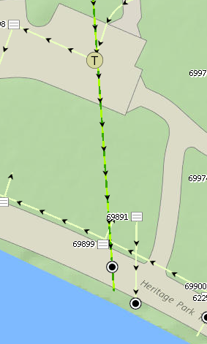

This filter location is inside Heritage Park in Olympia, WA. The approximate location is 47.043413, -122.906114.

1. 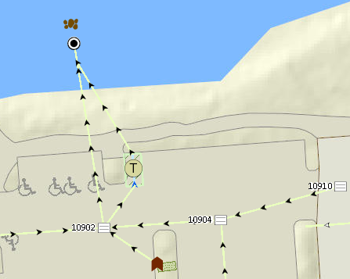

This filter is located in the parking lot of Anthony’s Hearthfire Grill in OIympia, WA. The approximate location is 47.058534, -122.904577.

**8) Summarize your methods of data analysis. If applicable, discuss any specific   
techniques, tests, or approaches that you will use to answer your research question.**

Phosphate concentrations found during my data collection will be compared from catch basins “upstream” the drainage system and “downstream” the drainage system in relation to the location of the cartridge filter. Concentrations from the outfall samples will be subtracted from the catch basin samples to quantify the amount of phosphate the filter removed from stormwater during the precipitation event.

For my data analysis methods, I would like to apply methodology from the program JMP to my data in order to determine significance in filtration means of the stormwater filter I am analyzing. This includes:

* Utilizing a paired T-test or independent sample test to determine filtration efficiencies of traditional stormwater infrastructure for different contaminants. This will consist of the relevant test for each contaminant measured as an “before and after” analysis.
* Analyzing phosphate levels present in my stormwater samples taken at catch basins and at the outfall. Once the difference has been determined, the total percent of phosphorus removed from stormwater can be found and compared to the manufacturer’s claims of 82%.

**9)Address the ethical issues raised by your thesis work. Include issues such as risks to**

**anyone involved in the research, as well as specific people or groups that might**

**benefit from or be harmed by your thesis work, perhaps depending on your results.**

**List any specific reviews you must complete first (e.g., Human Subjects Review or**

**Animal Use Protocol Form).**

Risks:

* The people to be involved in the research and data collection for my thesis will be myself and my thesis reader. There is risk involved in my data collection consisting of potentially hard to access areas, such as outfalls that are in or around water. To mitigate this risk, we will be using the “buddy system” to ensure personal safety. In addition, sampling on or near roadways during rainfall is dangerous as vehicles may not have clear visibility during these times. This stresses the importance of wearing reflective or safety colored clothing during field sampling and being aware of your surroundings and other vehicles while near roadways. In addition, downtown Olympia is where some of the sampling locations are located. It is important for my thesis reader and I to be aware of any dangerous individuals that could potentially be in the area.
* To mitigate the risk of personal injury, safety precautions and safety protocol will be discussed prior to conducting field sampling.

Benefit from work:

* The manufacturer of the stormwater filters I will be collecting data from may benefit from my results if the phosphorus removal efficiency I obtain supports or exceeds their phosphorus removal claims.

Harmed from work:

* The manufacturer of the stormwater filters I will be collecting data from may be harmed from my work if the results I obtain do not align or fall short of their phosphorus removal claims.

**10) List specific research permits or permissions you need to obtain before you begin**

**collecting data (e.g. landowner permissions, agency permits).**

I will be sampling runoff from the street or from an outfall. There are not permits required for either of these practices.

Outfalls entering a water body may be sampled from without permits or permission as long as they are not located on private property.

**11) Reflect on how your positionality as a researcher could affect your results and how**

**you will account for this in the research process.**

Addressing my positionality as a researcher to me means discussing how my personal identity will influence my perspective on my research. I worked for the City of Olympia’s private stormwater system maintenance program in 2021 under an internship where I first learned about and found a passion for stormwater infrastructure. Throughout this internship, I gained experiences working with unchanged and dirty stormwater filters that may influence my personal bias against their efficiency. Due to this, I will increase my awareness of this personal bias when conducting my data collection and analysis and use a program such as JMP to determine significance with the phosphate levels I have obtained.

**12) Provide at least a rough estimate of the costs associated with conducting your**

**research, if any. Provide details about each budget item so that the breakdown of the**

**final cost is clear.**

Chemical Reagents: There is a possibility that I will need to purchase chemical reagents in order to complete my data collection. If I am not able to use leftover reagents and will need to purchase, I am willing to pay this expense out of pocket. The estimated cost associated with reagents is approximately 150 dollars.

Transportation: Using the Evergreen State College’s reference to the Washington State Per Diem Rates for mileage reimbursement of $0.625 per mile, the following costs are associated with transportation for each day required to conduct field sampling:

49 total miles between my residence and the Evergreen State College / 29.09 miles per gallon for my vehicle = 1.68 gallons of gas required for journey

1.68 * $4.199 current Safeway gas price = $7.0729 required for one-way trip

$7.07 * 2 = $14.14 is required to travel to Evergreen State College and back to my residence. I am willing to pay this expense out of pocket to complete my data collection/analysis.

**13) Provide a detailed working outline of your thesis.**

List of figures and tables

Acknowledgements

Chapter 1: Introduction

Chapter 2: Literature review

* Section 1: History of Stormwater Media Filters/Traditional Stormwater Infrastructure
* Section 2: Phosphorus in Stormwater
* Section 3: Impervious Surfaces
* Section 4: Stormwater Media Filters for Phosphorus
* Section 5: Conclusion

Chapter 3: Methods

* Site Descriptions
* Data Collection
* Laboratory Analysis
* Data Analysis

Chapter 4: Results

* Phosphate Concentrations
* Stormwater Filter Removal Efficiencies

Chapter 5: Discussion

Chapter 6: Conclusion

Bibliography

**14) Provide a specific work plan and a timeline for each of the major tasks in the work**

**plan. Be as realistic and specific as you can at this point, including the deadlines for**

**Spring quarter.**

Submitted under “Work Plan 2023” along with this assignment.

**15) Who (if anyone), beyond your MES thesis reader, will support your thesis (in or**

**outside of Evergreen)? Be specific about who they are and in what capacity they will**

**support your thesis. If you are working with an outside agency or expert, be specific**

**about their expectations for your data analysis or publication of results**

Besides my MES thesis reader, I am not working with any outside agencies that are in support of my thesis.

**16) Provide the 5 most important references you have used to identify the specific   
questions and context of your topic, help with issues of research design and analysis,   
and/or provide a basis for interpretation. Annotate these references with notes on   
how they relate to/will be helpful for your thesis. For any other sources cited in your   
prospectus in other answers, provide a complete bibliographic citation here as well.**

(Adhikari et al., 2016)

This study evaluates different adsorbents in engineered stormwater media filters for phosphorus removal. This is very useful for my stormwater filter media literature review section. This paper also has good background information on impervious surfaces and urban runoff to use in the introduction to my literature review.

(Deng, 2020)

Low-cost adsorbents (often used in stormwater media filters) are becoming increasingly popular with engineered stormwater solutions. This paper analyzes if these adsorbents are effective at treating stormwater by looking into adsorbent efficiencies and chemical leaching potentials. I can use this data when comparing stormwater filter mediums and take into account possible adverse environmental effects.

(Egemose, 2018)

This study analyzes engineered stormwater filter media after treating stormwater for efficiency, clogging, and amount of phosphorus retained. This is useful to my paper sections on stormwater media filters.

(City of Olympia, n.d.)

The City of Olympia Private Stormwater Systems program GIS mapping of stormwater filters as well as stormwater drainage systems has been one of the most useful references for my proposed sites for data collection. I was able to use this map with my thesis reader to determine the locations best fit to sample with my research question.

(Wang et al., 2022)

This paper was very useful to my thesis in providing the implications of excess nutrients in stormwater, as well as how stormwater from urban cities carries these nutrients to receiving waters. This source was used in my “phosphorus in stormwater” portion of my literature review.

**Full Bibliography:**

Adhikari, R. A., Krishna, K. C. B., & Sarukkalige, R. (2016). Evaluation of phosphorus adsorption capacity of various filter materials from aqueous solution. *Adsorption Science & Technology*, *34*(4/5), 320–330.

Barbosa, A. E., Fernandes, J. N., & David, L. M. (2012). Key issues for sustainable urban stormwater management. *Special Issue on Stormwater in Urban Areas*, *46*(20), 6787–6798. <https://doi.org/10.1016/j.watres.2012.05.029>

City of Olympia. (n.d.). *Private Stormwater Systems* [GIS]. <https://olympiawa.maps.arcgis.com/apps/webappviewer/index.html?id=e33702d6bb554f83b0ff19425baeb854>

Contech Engineered Solutions, LLC. (2015). *The Stormwater Management Stormfilter®- PhosphoSorb® Field Performance Summary*. <https://www.conteches.com/Portals/0/Documents/Product%20Evaluation%20and%20%20Testing/Phosphosorb%20Performace%20Summary.pdf>

Deng, Y. (2020). Low-cost adsorbents for urban stormwater pollution control. *Frontiers of Environmental Science & Engineering*, *14*(5), 83. <https://doi.org/10.1007/s11783-020-1262-9>

Dietz, M. E., & Clausen, J. C. (2008). Stormwater runoff and export changes with development in a traditional and low impact subdivision. *Microbial and Nutrient Contaminants of Fresh and Coastal Waters*, *87*(4), 560–566. <https://doi.org/10.1016/j.jenvman.2007.03.026>

Egemose, S. (2018). Removal of particulate matter and phosphorus in sand filters treating stormwater and drainage runoff: A case study. *Urban Water Journal*, *15*(4), 388–391.

Jin, Z., Wang, J., Jiang, S., Yang, J., Qiu, S., & Chen, J. (2022). Fuel from within: Can suspended phosphorus maintain algal blooms in Lake Dianchi. *Environmental Pollution*, *311*, 119964. <https://doi.org/10.1016/j.envpol.2022.119964>

Kaeseberg, T., Kaeseberg, M., Zhang, J., Jawitz, J. W., Krebs, P., & Rao, P. S. C. (2018). The nexus of inhabitants and impervious surfaces at city scale—Wastewater and stormwater travel time distributions and an approach to calibrate diurnal variations. *Urban Water Journal*, *15*(6), 576–583.

Min, S.-H., Eberhardt, T. L., & Min Jang. (2007). Base-Treated Juniper Fiber Media for Removing Heavy Metals in Stormwater Runoff. *Polish Journal of Environmental Studies*, *16*(5), 731–738.

Nguyen, H. H., Gericke, A., & Venohr, M. (2022). Importance of different imperviousness measures for predicting runoff and nutrient emissions from non-urban and urban land-uses at large spatial coverage. *Journal of Environmental Management*, *315*, 115105. <https://doi.org/10.1016/j.jenvman.2022.115105>

Okaikue-Woodi, F. E. K., Cherukumilli, K., & Ray, J. R. (2020). A critical review of contaminant removal by conventional and emerging media for urban stormwater treatment in the United States. *Water Research*, *187*, 116434. <https://doi.org/10.1016/j.watres.2020.116434>

Parsons, A. J., Cooper, J., & Wainwright, J. (2015). What is suspended sediment? *Earth Surface Processes and Landforms*, *40*(10), 1417–1420. <https://doi.org/10.1002/esp.3730>

Shafqat, M. N., & Pierzynski, G. M. (2013). Soil test phosphorus dynamics in animal waste amended soils: Using P mass balance approach. *Chemosphere*, *90*(2), 691–698. <https://doi.org/10.1016/j.chemosphere.2012.09.050>

Skotnicki, M., & Sowiński, M. (2015). The influence of depression storage on runoff from impervious surface of urban catchment. *Urban Water Journal*, *12*(3), 207–218.

Smith, J. S., Winston, R. J., Tirpak, R. A., Wituszynski, D. M., Boening, K. M., & Martin, J. F. (2020). The seasonality of nutrients and sediment in residential stormwater runoff: Implications for nutrient-sensitive waters. *Journal of Environmental Management*, *276*, 111248. <https://doi.org/10.1016/j.jenvman.2020.111248>

Wang, Y., Thompson, A. M., & Selbig, W. R. (2022). Predictive models of phosphorus concentration and load in stormwater runoff from small urban residential watersheds in fall season. *Journal of Environmental Management*, *315*, 115171. <https://doi.org/10.1016/j.jenvman.2022.115171>

Wu, T., & Sansalone, J. (2013). Phosphorus Equilibrium. II: Comparing Filter Media, Models, and Leaching. *Journal of Environmental Engineering*, *139*(11), 1325–1335.

Zank, B., Bagstad, K. J., Voigt, B., & Villa, F. (2016). Modeling the effects of urban expansion on natural capital stocks and ecosystem service flows: A case study in the Puget Sound, Washington, USA. *Landscape and Urban Planning*, *149*, 31–42. <https://doi.org/10.1016/j.landurbplan.2016.01.004>