### Thesis Prospectus 2022-23

**Name:** Rachelle Clausen  **ID Number:** A00382580

**Email:** rachelle.l.clausen@evergreen.edu

**Student Final Submission (date):** 12/05/2022

**Faculty Reader Approval (date):**

**MES Director Approval (date):**

1. **Working title of your thesis[1].**

Quantifying Soil Organic Matter of Wetland Mitigation Sites at the Washington State Department of Transportation

1. **In 250 words or less, summarize the key background information needed to understand your research problem and question.**

The Washington State Department of Transportation (WSDOT) plays a significant role in compensatory wetland mitigation throughout the state. In compliance with federal, state, and local policies, WSDOT follows strict guidelines to compensate for loss of wetland acreage and function due to roadway development (Ballantine et al., 2011; Schafer and Ossinger, 1990). To maintain best practices, WSDOT continuously seeks improvements in their commitment to ‘no-net-loss of wetlands’ based on adaptive management principles (Ballantine et al., 2011; Schafer and Ossinger, 1990). Throughout the literature, scholars debate the efficacy of compensatory wetland mitigation in practice. For instance, Kentula (2000) expresses that mitigation project plans tend to focus on compliance success, overlooking the importance of functional characteristics in evaluating site development. Ballantine et al. (2011) suggest that this void could be filled by incorporating performance standards for soils into quantitative monitoring methodologies. Many studies have identified soil organic matter (SOM) to be a reliable indicator of wetland soil health (Stapanian et al., 2013; Brown and Norris, 2017; Bentley et al., 2022; Stalnaker, 2015; Karlen et al., 1997; Ballantine et al., 2011; Bruland and Richardson, 2006; Ahn and Jones, 2013; Hossler and Bouchard, 2010; Craft et al., 2003; Windham et al., 2004; Ossinger, 1989). Thus, there is an opportunity to take a deeper look at the role that soils play in the success of WSDOT’s mitigation projects through comparison of SOM content and performance standard success.

1. **State your research question(s).**

Primary Question: Is there a relationship between soil organic matter content and performance standard success at WSDOT’s wetland mitigation sites?

Potential Direction: Is there a difference of soil organic matter content and/or site success between ‘created’ and ‘enhanced’ mitigation types?

1. **Situate your research problem within the relevant literature. What is the theoretical and/or practical framework of your research problem?**

Previous studies have expressed concern of the lack of attention given to functional elements, such as soil composition, in wetland mitigation project performance standards (Matthews & Endress, 2008; Windham et al., 2004; Hossler et al., 2011; Xu et al., 2019; Kentula, 2000). Hossler et al. (2011) explain that current methods in wetland mitigation are not sufficient in meeting no-net-loss requirements due to the absence of nutrient-related metrics in wetland monitoring. When investigated quantitatively, researchers have found soil organic carbon content to be a significant indicator of overall wetland health (Hossler & Bouchard, 2010; Hossler et al., 2011). Wetland soils generally hold high amounts of soil organic matter, as slow decomposition takes place under the anaerobic conditions typical of wetlands (Ballantine et al., 2011). Sufficient nutrient cycling within wetland ecosystems depends on such characteristics, and without the cycling of nutrients, plants will have a difficult time establishing on the landscape (Ballantine et al., 2011). As stated by Ballantine et al. (2011), soil organic matter is essential to the development of vegetation, “…holding a large proportion of nutrients, cations, and trace elements critical for their growth.” (p. 1483). Thus, quantifying soil organic carbon at WSDOT wetland sites could provide useful information about site progress and could help illustrate the importance of soil quality in the development of wetland mitigation projects (Hossler & Bouchard, 2010; Stalnaker, 2015).

WSDOT currently measures site success through vegetative parameters, so even if soil indicators are not on the horizon for quantitative monitoring, soil composition is still a critical aspect of vegetative success. When sites fail to pass performance standards, it is often difficult to identify the reason. Because of the importance of proper soil composition to wetland development, it is possible that the culprit lies within the soils.

In a 2005 study by Bergdolt et al., researchers evaluate compliance of WSDOT wetland mitigation sites. Their study revealed only one site out of thirty which met all performance standards, and a handful of sites had “significant shortfalls” (Bergdolt et al., 2005). Furthermore, their analysis showed that, out of 173 total performance standards across all sites, only 96 were met (Bergdolt et al., 2005). Authors hypothesize that factors such as site selection, site design, site maintenance, and permit requirements could explain the deficits (Bergdolt et al., 2005). In this regard, there is a chance that soils could be connected to any/all of the potential reasons stated in their study.

1. **Explain the significance of this research problem. Why is this research important? What are the potential contributions of your work? How might your work advance scholarship?**

Wetlands are critical to both local and global ecological health as they provide a wealth of ecosystem functions. Despite recent focus on wetland mitigation practices, our wetlands continue to decline—both in acreage and in quality. WSDOT’s current quantitative wetland monitoring protocols focus primarily on vegetation indicators; however, studies have demonstrated the need for a more inclusive approach to wetland monitoring. Quantitative soil data will provide critical insight to WSDOT that could help improve the mitigation process. For instance, soil parameters are not included in the benchmark performance standards set for quantitative monitoring years—the current methodology only includes soil indicators in the qualitative data. This research could spark a conversation about the need to give more attention to soil in future mitigation planning. Additionally, there may be potential connections related to site history, construction methods, soil amendments, etc. which could contribute knowledge for additional improvements of these wetland mitigation projects. Improvements would mean increased efficiency for WSDOT, as restoration crews would spend less time returning to problem sites to replant, spray, etc. This would hopefully serve as a long-term investment to improve the overall success rate in meeting performance standards and getting sites closed out on time. This research will allow WSDOT to look at the soil composition of their wetland mitigation sites through a quantitative lens, providing feedback for future construction and monitoring practices. More broadly, the information from this study will contribute to ongoing conversation about the effectiveness of compensatory wetland mitigation and monitoring practices in fulfilling critical wetland functions.

1. **Summarize your study design[2]. If applicable, identify the key variables in your study. What is their relationship to each other? For example, which variables are you considering as independent (explanatory) and dependent (response)?**

Before going into the field, I plan to map out each site in ArcGIS Pro and designate random sample points (perhaps a few per ecological zone at each site), collect two samples per point (one to send to the lab and one for a more qualitative, hands-on analysis). Then I would compile monitoring results from each site and see how ‘success’ relates to specific indicators of wetland soil health (e.g., soil organic carbon, nitrogen, texture/type, etc.) based on site and zone context. My dependent variable will be the monitoring results, which will demonstrate site progress based on fulfilling required performance standards. My independent variable will be the soil composition of samples collected at each site, specifically the soil organic carbon content. These will be used to identify if there is a relationship or not between wetland soil health and site success.

1. **Describe the data that will be the foundation of your thesis. Will you use existing data, or gather new data (or both)? Describe the process of acquiring or collecting data[3].**

I will be gathering new data (through soil sampling) and utilizing existing data published by WSDOT (e.g., annual monitoring reports, qualitative soil data, etc.). Details surrounding data collection can be found in the answer above. For existing resources, monitoring reports will show each performance standard for each site, as well as the quantitative results (including confidence interval) *see below. In addition, these results include a ‘Site Description’ section to describe the purpose of the mitigation. Further details in these reports include specific details regarding the sample design used to determine results (*see below) and an overall discussion of site development, including quantitative remarks about hydrology indicators (i.e., soil characteristics). In some cases, sites will have a standard for wetland delineation and/or wetland hydrology (such as seen in example b below). I will include screenshots at the end* to show an example of the relevant data included in a delineation report (soils, hydrology, precipitation).

*\*Example of 2 Year-10 sites - one meeting all standards (a) and one not meeting the only standard measured qualitatively (b)*

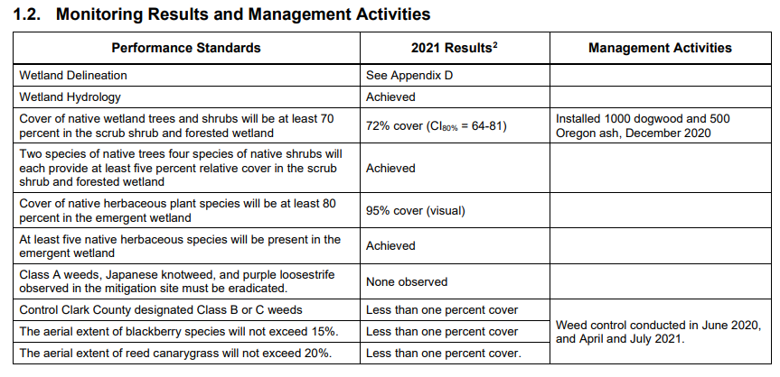a)

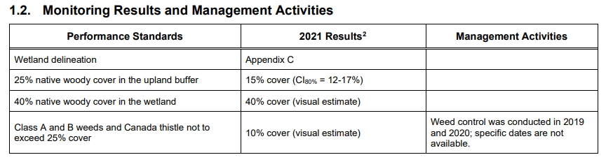b)

*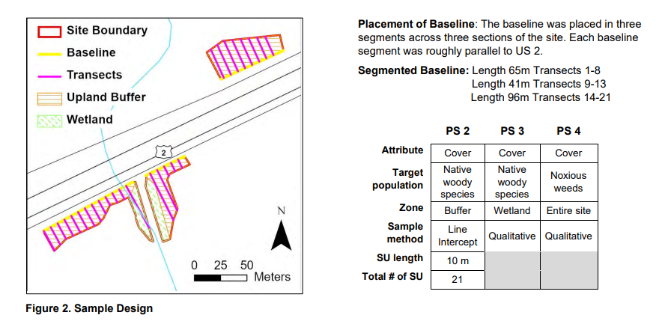*Sample Design:*

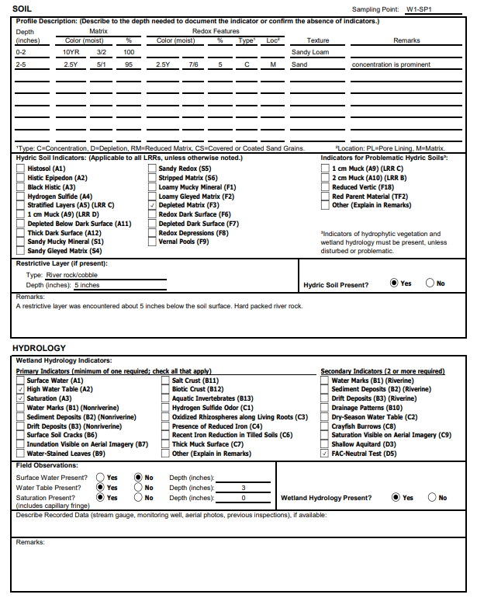*\*Wetland Delineation:*

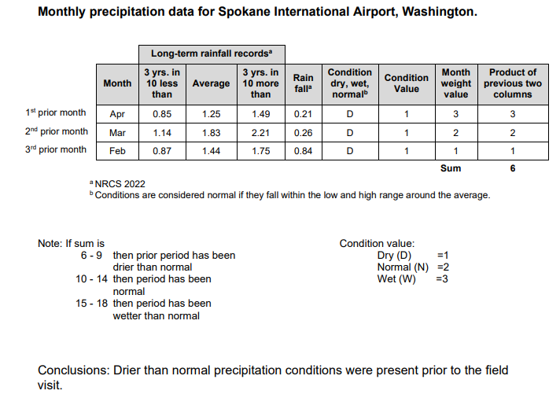

1. **Summarize your methods of data analysis. If applicable, discuss any specific techniques, tests, or approaches that you will use to answer your research question.**

A sample of sites will be selected based on age and mitigation type criteria. Each site will be identified in ArcGIS Pro and categorized by ecological zone. Two random sample points per zone will be designated for soil sample collection. Soil samples will be sent to the lab for analysis of soil organic matter (SOM) content. SOM content will then be compared with performance standard results from the most recent quantitative monitoring year. Finally, MANOVA and Two-Way ANOVA tests will be used for statistical analysis of results.

After further discussion, I could analyze using a t-test, for example, if looking to compare by mitigation type (creation vs enhancement) to determine if the mean levels of SOC are similar in creation vs enhancement sites. I could also use a paired t-test if looking only at sites that include zones of both enhancement and creation to look at site-level differences.

1. **Address the ethical issues[4] raised by your thesis work. Include issues such as risks to anyone involved in the research, as well as specific people or groups that might benefit from or be harmed by your thesis work, perhaps depending on your results. List any specific reviews you must complete first (e.g., Human Subjects Review or Animal Use Protocol Form).**

As my research will be focused on the Washington State Department of Transportation’s Wetlands Program, I will need to consider any potential impacts to the agency. For example, if my results show alarmingly low levels of SOM at all sampled sites, this could make WSDOT look bad and perhaps lead to outside concern to the integrity of their work to compensate for wetland loss. Generally speaking, I will just need to keep in mind that I am not only representing myself through conducting this research, I will be communicating results based on the data collected by WSDOT staff (monitoring reports) and the data collected at WSDOT sites (soil samples); thus, I will be representing the work of WSDOT as well.

1. **List specific research permits[5] or permissions you need to obtain before you begin collecting data (e.g. landowner permissions, agency permits).**

I am currently waiting to hear back from Kristen Andrews (Wetland Monitoring Manager) about what kind of approval that I will need to gain access to the sites, but it will involve some sort of safety paperwork. Once my sample of sites is established, I will also need to follow up on specific access requirements (i.e., keys to enter).

1. **Reflect on how your positionality as a researcher could affect your results and how you will account for this in the research process[6].**

Since I was an intern for WSDOT’s Wetland Monitoring Program in 2021, I could be considered a previous employee. The internship was an incredible experience and I’d be thrilled to work for them in the future. This could mean that my positionality will push me to conduct the best research that I am capable of, but it could also mean that I want to provide them significant results while also maintaining a positive relationship with staff and management. I will account for this by communicating unbiased results and remaining neutral as a researcher. I will also remind myself that unproven hypotheses and insignificant relationships can still be informative.

1. **Provide at least a rough estimate of the costs associated with conducting your research, if any.  Provide details about each budget item so that the breakdown of the final cost is clear.**

I still need to decide on which lab to send my soil samples for analysis, but this will likely be the largest cost for my study. Using the Department of Ecology’s certified laboratory database (<https://apps.ecology.wa.gov/laboratorysearch/SearchMatrix.aspx>), I have been narrowing down my list to the labs that use the loss on ignition (LOI) method to analyze for soil organic matter. Based on prices listed online (most labs offer quotes, not listed prices), I estimate that this will cost around $500 for all samples. To collect samples, I will need to purchase a soil probe tool (~ $20) and soil containers (~ $15). Lastly, I will be traveling to each site, so I will need to account for commuting expenses. With the government mileage rate of 58.5 cents per mile and an estimated sample of 10 sites, I expect gas expenses to be around $500 total. This brings the total cost of the research to approximately $1035.

1. **Provide a detailed working outline of your thesis.**

-Abstract

1. Introduction
2. Literature Review
   1. Intro
   2. Compensatory Wetland Mitigation
   3. Wetland Monitoring
   4. Wetland Soils
   5. Conclusion
3. Study Area
   1. Overview of Sites
   2. Site History
   3. Construction Methods
4. Methodology
   1. Data Collection
   2. Lab Analysis
   3. Performance Standards Review
   4. Statistical Analyses
5. Results
6. Discussion
7. Conclusion

-References

-Appendices

1. **Provide a specific work plan and a timeline for each of the major tasks in the work plan. Be as realistic and specific as you can at this point, including the deadlines for Spring quarter.**

After discussing this project with WSDOT staff, it may not be ideal to collect soil samples during the winter for various reasons. So, there is a good chance that I will be filing for an extension so that I can conduct my soil sampling during late winter/early spring. I will be sending soil samples to a lab, so I will need to consider wait time in obtaining results. While samples are being tested, I will focus on reviewing monitoring reports of each site, including results of all performance standards, and organizing the data in preparation for statistical analysis. Assuming all goes well, I should be able to complete data analysis during spring, and wrap up my research to complete the paper by the end of Summer 2023.

1. **Who (if anyone), beyond your MES thesis reader, will support your thesis (in or outside of Evergreen)? Be specific about who they are and in what capacity they will support your thesis. If you are working with an outside agency or expert, be specific about their expectations for your data analysis or publication of results.**

Jocelyn Munoz (Wetland Biologist) will be my primary contact at WSDOT throughout this project, though additional staff may play smaller roles to support. Jocelyn will be able to provide me with the existing data needed for my analyses, assist in acquiring access to mitigation sites, offer feedback and insight on behalf of the Wetlands Program, and relay messages and/or schedule meetings with other WSDOT staff to discuss perspectives of the issue, needs of the Wetlands Program, and general comments/concerns pertaining to the research. I am waiting for a response about specific expectations, however, in our previous meeting, staff expressed excitement for any knowledge gained from this research as it could potentially support the argument that soils are not getting enough attention.

1. **Provide the 5 most important references you have used to identify the specific questions and context of your topic, help with issues of research design and analysis, and/or provide a basis for interpretation. Annotate these references with notes on how they relate to/will be helpful for your thesis. For any other sources cited in your prospectus in other answers, provide a complete bibliographic citation here as well.**

Ballantine, K., Schneider, R., Groffman, P., and Lehmann, J. (2011). Soil properties and

vegetative development in four restored freshwater depressional wetlands. *Soil Science Society of America Journal, 76*: 1482-1495. doi:10.2136/sssaj2011.0362

Bell, M. (2012). Regulatory wetland monitoring: Principles and evolving techniques

within Washington State Department of Transportation. Oregon State University (Master’s Thesis).

Bentley, S. B., Tomscha, S. A., & Deslippe, J. R., (2022). Indicators of wetland health

improve following small-scale ecological restoration on private land. *Science of the Total Environment, 837*(2022): 15576. http://dx.doi.org/10.1016/j.scitotenv.2022.155760

Bentley et al. (2022) provide a realistic experimental approach to assessing success of wetland restoration by comparing 18 restored wetlands to 18 unrestored wetlands in New Zealand. The authors analyze various indicators of wetland health under three categories: plant indicators, soil indicators, and microbial indicators. The design of this experiment will be critical for my research as it provides a wide range of attributes that can be used to evaluate WSDOT’s wetland mitigation sites. As the authors explain, “Understanding the effectiveness of wetland restoration requires that appropriate indicators of ecosystem health are monitored.” (p. 2). Additionally, this article was published this year, so it is relevant to the current status of wetland research and references a wealth of sources on the topic. Bentley et al. (2022) note a potential challenge in this research, stating that “The appropriate biophysical indicators of ecosystem health vary by ecosystem type, and defining indicators of wetland health can be particularly challenging because wetlands are so diverse and heterogeneous.” (p. 2). For this reason, their study looks at many potential indicators to capture the diversity in wetland types. Furthermore, the study goes into detail about how they used statistical analyses to evaluate their results, which will be an important part of my own thesis research process.

Bergdolt, F. S., Prehmus, C. A., and Barham, J. B. (2005). An evaluation of wetland

mitigation site compliance at the Washington State Department of Transportation. Washington State Department of Transportation, Wetland Assessment & Monitoring Program: Olympia, WA.

Brown, J., and Norris, M. D. (2017). Detecting soil and plant community changes in

restored wetlands using a chronosequence approach. *Wetlands Ecology & Management, 26:* 299-314. <https://doi.org/10.1007/s11273-017-9574-7>.

Bruland, G. L., and Richardson, C. J. (2006). Comparison of soil organic matter in

created, restored and paired natural wetlands in North Carolina. *Wetlands Ecology & Management, 24*: 245-251. DOI 10.1007/s11273-005-1116-z.

Confer, S. R. and W. A. Niering. (1992). Comparison of created and natural freshwater

emergent wetlands in Connecticut. *Wetland Ecology and Management 2*(3): 143-156.

Horner, R. R., and Raedeke, K. J. (1989). *Guide for wetland mitigation project*

*monitoring.* Operational Draft, Report WA-RD 195.1. Washington State Department of Transportation: Olympia, WA.

Hossler, K., and Bouchard, V. (2010). Soil development of carbon-based properties in

created freshwater marshes. *Ecological Applications, 20*(2): 539-553.

Hossler, K., Bouchard, V., Fennessy, M. H., Frey, S. D., Anemaet, E., and Herbert, E.

(2011). No-net-loss not met for nutrient function in freshwater marshes: Recommendations for wetland mitigation policies. *Ecosphere, 2*(7): 1-36.

Kentula, M. E. (2000). Perspectives on setting success criteria for wetland restoration.

*Ecological Engineering, 15*: 199-209.

Kentula (2000) investigates how wetland mitigation practices can be improved through the ways in which their success is evaluated. She makes a critical point, explaining that “The task of determining the success of wetland restoration has long been challenging and sometimes contentious because success is an imprecise term that means different things in different situations and to different people.” (p. 199). The article defines the differences between compliance success, functional success, and landscape success, while pushing for a more holistic criteria that encompasses all three. Kentula (2000) notes that vegetation measurements are often used as benchmarks for success in wetland mitigation, however, attributes of soils, wildlife, and hydrology are frequently overlooked. This article gives further justification for pursuing a field-based experiment, as the author recommends dealing with uncertainty with structured research that involves hypothesis testing, model building, and adaptive management. Kentula (2000) elaborates, “In this way, options can be systematically evaluated and needs for corrective actions identified when a project is not progressing toward goals.” (p. 199). This approach not only provides more accurate data for specific projects, but also generates knowledge that can improve overall management practices. Kentula’s (2000) research is essential to understanding the way we look at mitigation and serves as a jumping-off point for further research. Her study uncovers that, “Ecologically, there is a need to go beyond the traditional documentation of site attributes, such as vegetation cover, and address system function.” (p. 202). By incorporating more ecological indicators into WSDOT’s qualitative monitoring practices, such as sampling soils, they may be able to improve success in reaching performance standards for their wetland mitigation sites.

Matthews, J. W., and Endress, A. G. (2008). Performance criteria, compliance success,

and vegetation development in compensatory mitigation wetlands. *Environmental Management*, 41: 130-141.

NRC (Committee on Wetland Mitigation; National Research Council). (2001).

Compensating for Wetland Loss Under the Clean Water Act. Washington, DC: National Academy Press.

Race, M. S., and Fonseca, M. S. (1996). Fixing compensatory mitigation: What will it

take? *Ecological Applications, 6*(1): 94-101. <https://www.jstor.org/stable/2269556%0D>

This article addresses some of the major concerns raised by the scientific community regarding wetland mitigation practices. As this issue is still relevant today, this article provides background on why improving such practices is important. Race and Fonseca (1996) found that the majority of previous permit-linked projects have been unsuccessful. The authors point to an overarching challenge of progress, stating that, “Although hardly responsible for the majority of national wetland losses, the practice of compensatory mitigation remains a serious concern because it is a bartering scheme that trades permission to damage a known quantity of wetland area for the promise of some kind of replacement, sometimes at locations away from the impacted area.” (p. 94). This is a great explanation of the concerns surrounding wetland mitigation still to this day. Additionally, this article provides some justification for incorporating field- and lab-based experiments into the matter, noting that “…much of the work on mitigation remains outside the peer-reviewed literature.” (p. 95). Their study shows that much of the literature-based research has been established over the years, so it is crucial for ecologists to move towards more qualitative methods in order to advance the foundational science surrounding wetland mitigation.

Savage, M. S. (1994). An evaluation of the wetland monitoring program of the

Washington State Department of Transportation. *The Evergreen State College (Thesis):* Olympia, WA.

This thesis will be critical to improving my understanding of wetland mitigation practices at WSDOT. Savage (1994) provides a deep-dive into the foundational information of WSDOT’s wetland monitoring program—she uses both the literature and interviews to describe the state of the program at the time. As I was an intern with WSDOT in 2021, it will be interesting to uncover any differences to the program over the past 30 years. This research will serve as an additional reference to monitoring protocols outside of the grey literature published by state agencies as her study adds a personal element with the interviews included. Savage (1994) points out the pros and cons of WSDOT’s wetland monitoring program while also providing useful recommendations for improvement. Though this thesis is a bit dated, it is a great preliminary resource to refresh my memory of WSDOT’s specific protocols from another student’s perspective.

Schafer, J. A., and Ossinger, M. C. (1990). Washington State Department of

Transportation Wetland Monitoring Program. Transportation Research Record 1366. Olympia, WA: Washington State Department of Transportation, Environmental Branch.

Stalnaker, C. (2015). Soil organic carbon content of compensatory wetland mitigation

projects in Auburn, Washington. The Evergreen State College (Thesis): Olympia, WA.

Stalnaker’s (2015) thesis provides a well-organized methodology for evaluating wetland soils and species richness at the City of Auburn’s wetland mitigation sites. Her paper includes a thorough overview of the history and importance of wetlands in Washington and her literature review section will be an important resource in developing background research. Results of the study show significance in the variation of soil organic carbon content at restored vs. unrestored mitigation sites. The information provided by her results in general will help direct my own thesis research and will be a reference to compare my results to. Furthermore, Stalnaker (2015) gives a comprehensive summary of critical nutrients in healthy wetland soils. Her methodology is quite detailed and can serve as a reference for experimental design. Lastly, I plan to use her bibliography to discover additional sources of relevant knowledge.

Stapanian, M. A., Adams, J. V., Fennessy, M. S., Mack, J., and Micacchion, M. (2013).

Candidate soil indicators for monitoring the progress of constructed wetlands toward a natural state: A statistical approach*. Wetlands, 33*: 1083-1094.

Provides an example of soil indicators that could be used in my study as well as a good reference for experimental design.

United States Environmental Protection Agency (EPA). (2022). Overview of Clean

Water Act Section 404. Retrieved November 10, 2022, from <https://www.epa.gov/cwa-404/overview-clean-water-act-section-404>.

Washington State Department of Transportation (WSDOT). (2022). Environmental

Manual M 31-11.26. Engineering & Regional Operations: Development Division, Environmental Services Office. Retrieved November 14, 2022, from <https://www.wsdot.wa.gov/publications/manuals/fulltext/m31-11/em.pdf>

Windham, L., Laska, M. S., and Wollenberg, J. (2004). Evaluating urban wetland

restorations: Case studies for assessing connectivity and function. *Urban Habitats, 2*(1): 130-146.

Xu, S., Liu, X., Li, X., and Tian, C. (2019). Soil organic carbon changes following

wetland restoration: A global meta-analysis. *Geoderma, 353*: 89-96.

1. You are not locked into this title; we want you to identify the main point or topic of your thesis.
2. You might discuss selection of case studies, sampling methods, experimental design, and/or specific hypotheses you will test. You should also address any specialized knowledge or skills that are necessary to complete the research.
3. If you are planning to use existing data, explain the specific source, contact information, arrangement with collaborating agencies, and expectations about use of data and final products of your research. If you are planning to gather new data, describe specific methods, time, place, and equipment that will be required.
4. If you’re not sure where to start, consult a ‘Code of Ethics’ or other similar document from an academic society in an applicable field of study.
5. If you are collecting ANY samples or data, even observational data, on public lands (city, county, state and/or federal) it is your responsibility to find out the permit requirements BEFORE you collect data. Conducting research with tribal members/on tribal lands will have different and additional requirements.
6. Your *positionality as a researcher* refers to the fact that one’s “…beliefs, values systems, and moral stances are as fundamentally present and inseparable from the research process as [one]’s physical, virtual, or metaphorical presence when facilitating, participating and/or leading the research project…” (The Weingarten Blog 2017).